Snapshots

What Are Snapshots in Version Control?
# Source: AI Source: Provided by: [Data Path: Persons Table -> ID Column: 1, Name_En Column: Motasem Essam] -> From: [ChatGPT] on [2/15/2026]
Snapshot is basically a commit. Every time you make a commit, you create a snapshot of your project that serves as a saved state you can go back to.
A snapshot is a record of your project’s state at a specific point in time — like a photo of your files.
In version control systems (like Git), a snapshot saves:
- The contents of files
- Their structure (folders, filenames)
- Metadata (who made the change, when, and why)

Think of It Like:
# Source: AI Source: Provided by: [Data Path: Persons Table -> ID Column: 1, Name_En Column: Motasem Essam] -> From: [ChatGPT] on [2/15/2026]
🧾 A snapshot is a "save point" in your project.
You can return to it, compare it with others, or branch off from it.

What exactly is the Snapshots?

Answer
# Source: AI Source: Provided by: [Data Path: Persons Table -> ID Column: 1, Name_En Column: Motasem Essam] -> From: [ChatGPT] on [2/15/2026]
A snapshot is a record of the exact content of your files at a given moment.
- Technically, it’s the state of all staged files stored in the Git repository.
- It is not a copy of the folder in the normal sense, but a Git-internal representation of file contents and metadata.

Internally in Git
# Source: AI Source: Provided by: [Data Path: Persons Table -> ID Column: 1, Name_En Column: Motasem Essam] -> From: [ChatGPT] on [2/15/2026]
When you make a commit:
- Git looks at the Staging Area.
- Git calculates a hash for each file (SHA-1 hash).
- Git stores:
  - The contents of the file (if changed since last snapshot)
  - File metadata (permissions, path)
  - A pointer to previous commit (history link)
This stored data is what Git calls a snapshot.

Key facts
# Source: AI Source: Provided by: [Data Path: Persons Table -> ID Column: 1, Name_En Column: Motasem Essam] -> From: [ChatGPT] on [2/15/2026]
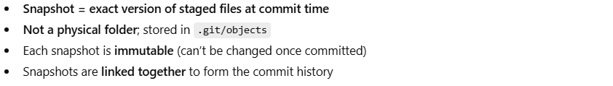
- Snapshot = exact version of staged files at commit time
- Not a physical folder; stored in .git/objects
- Each snapshot is immutable (can’t be changed once committed)
- Snapshots are linked together to form the commit history

Analogy
# Source: AI Source: Provided by: [Data Path: Persons Table -> ID Column: 1, Name_En Column: Motasem Essam] -> From: [ChatGPT] on [2/15/2026]
Think of snapshots as:
- Photos of your files → each snapshot is a photo at a particular moment
- You don’t store every photo fully if parts didn’t change → Git optimizes storage by storing only differences

Example
# Source: AI Source: Provided by: [Data Path: Persons Table -> ID Column: 1, Name_En Column: Motasem Essam] -> From: [ChatGPT] on [2/15/2026]
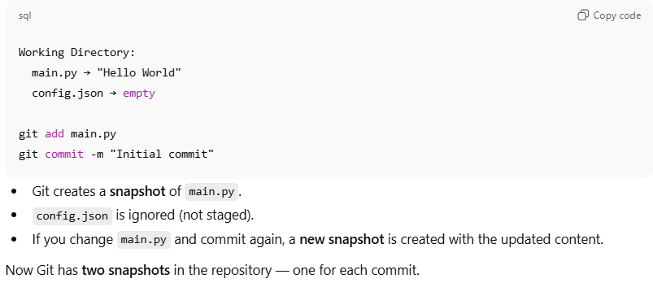
Working Directory:
main.py → "Hello World"
config.json → empty

git add main.py
git commit -m "Initial commit"
- Git creates a snapshot of main.py.
- config.json is ignored (not staged).
- If you change main.py and commit again, a new snapshot is created with the updated content.
Now Git has two snapshots in the repository — one for each commit.

✅ One-line exact definition:
# Source: AI Source: Provided by: [Data Path: Persons Table -> ID Column: 1, Name_En Column: Motasem Essam] -> From: [ChatGPT] on [2/15/2026]
A snapshot is Git’s internal record of the exact content and state of staged files at the moment of a commit.

Example:
# Source: AI Source: Provided by: [Data Path: Persons Table -> ID Column: 1, Name_En Column: Motasem Essam] -> From: [ChatGPT] on [2/15/2026]
You have a project folder like this:
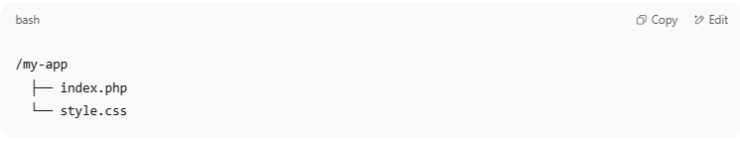
/my-app
├── index.php
└── style.css

- You make a change to index.php
- You commit that change
- Git stores a snapshot of both files (not just the change)
Later, if you mess up your code, you can:
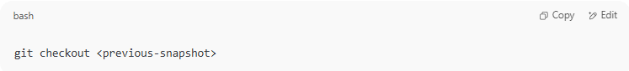
git checkout <previous-snapshot>

And restore your project to that exact state.

what is relation of Snapshots and Staging Area

Relationship between Snapshots and the Staging Area
# Source: AI Source: Provided by: [Data Path: Persons Table -> ID Column: 1, Name_En Column: Motasem Essam] -> From: [ChatGPT] on [2/15/2026]
- Working Directory → Staging Area
  - You edit files in the Working Directory (your project folder).
  - When you run git add <file>, Git copies the current content of that file into the Staging Area.
  - Think of the Staging Area as a preview of what will go into the next snapshot.
- Staging Area → Snapshot (Commit)
  - When you run git commit, Git takes the files in the Staging Area and records a snapshot of them.
  - This snapshot is now permanent in the repository.

Key Points
# Source: AI Source: Provided by: [Data Path: Persons Table -> ID Column: 1, Name_En Column: Motasem Essam] -> From: [ChatGPT] on [2/15/2026]
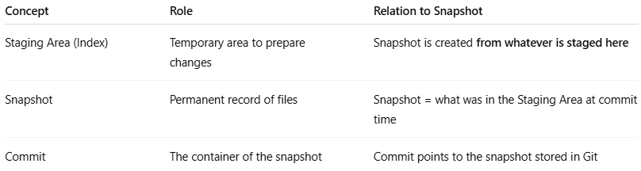
Concept | Role | Relation to Snapshot
Staging Area (Index) | Temporary area to prepare changes | Snapshot is created from whatever is staged here
Snapshot | Permanent record of files | Snapshot = what was in the Staging Area at commit time
Commit | The container of the snapshot | Commit points to the snapshot stored in Git

Analogy
# Source: AI Source: Provided by: [Data Path: Persons Table -> ID Column: 1, Name_En Column: Motasem Essam] -> From: [ChatGPT] on [2/15/2026]
- Working Directory = your live workspace
- Staging Area = what you put on your clipboard
- Snapshot = take a photo of your clipboard
- Commit = save that photo in an album
So: Staging Area → you choose → Snapshot → permanent

Example
# Source: AI Source: Provided by: [Data Path: Persons Table -> ID Column: 1, Name_En Column: Motasem Essam] -> From: [ChatGPT] on [2/15/2026]
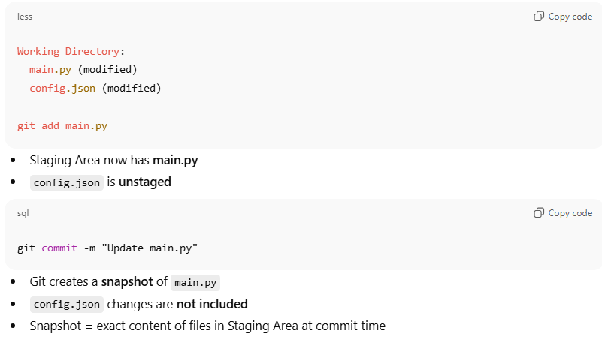
Working Directory:
main.py (modified)
config.json (modified)

git add main.py
- Staging Area now has main.py
- config.json is unstaged
git commit -m "Update main.py"
- Git creates a snapshot of main.py
- config.json changes are not included
- Snapshot = exact content of files in Staging Area at commit time

💡 Memory trick:
# Source: AI Source: Provided by: [Data Path: Persons Table -> ID Column: 1, Name_En Column: Motasem Essam] -> From: [ChatGPT] on [2/15/2026]
- Working Directory = edit
- Staging Area = prepare
- Snapshot = photo of staged files
- Commit = store photo permanently ✅

Snapshots vs Diffs
# Source: AI Source: Provided by: [Data Path: Persons Table -> ID Column: 1, Name_En Column: Motasem Essam] -> From: [ChatGPT] on [2/15/2026]
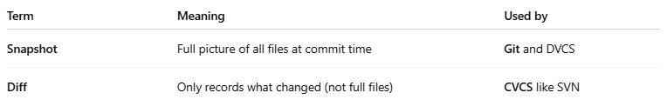

Term | Meaning | Used by
Snapshot | Full picture of all files at commit time | Git and DVCS
Diff | Only records what changed (not full files) | CVCS like SVN
Git is smarter: it stores snapshots, but optimizes storage so unchanged files aren’t duplicated.

Benefits of Snapshots
# Source: AI Source: Provided by: [Data Path: Persons Table -> ID Column: 1, Name_En Column: Motasem Essam] -> From: [ChatGPT] on [2/15/2026]
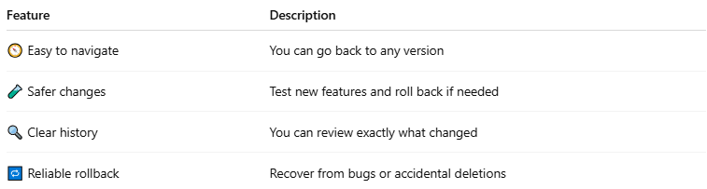

Feature | Description
🧭 Easy to navigate | You can go back to any version
🧪 Safer changes | Test new features and roll back if needed
🔍 Clear history | You can review exactly what changed
🔁 Reliable rollback | Recover from bugs or accidental deletions

Summary:
# Source: AI Source: Provided by: [Data Path: Persons Table -> ID Column: 1, Name_En Column: Motasem Essam] -> From: [ChatGPT] on [2/15/2026]
A snapshot in version control is:
- A full record of your project at one point in time
- Like a "checkpoint" or "save" of your work
- Used to view history, undo mistakes, and collaborate safely

